**Name: Session:**

**Programming I**

**Lab Exercise 10.7.2019**

For each of these problems, you are to print out your documented source code, attach it to the back of this sheet and turn it in.

1. Write functions

def sphereVolume(r):

def sphereSurface(r):

def cylinderVolume(r, h):

def cylinderSurface(r, h):

def coneVolume(r, h):

def coneSurface(r, h):

that compute the volume and surface area of a sphere with radius r, a cylinder with a

circular base with radius r and height h, and a cone with a circular base with radius r

and height h. Then write a program that prompts the user for the values of r and h,

calls the six functions, and prints the results.

1. Write a graphical application that displays a checkerboard with 64 squares, alternating white and black.

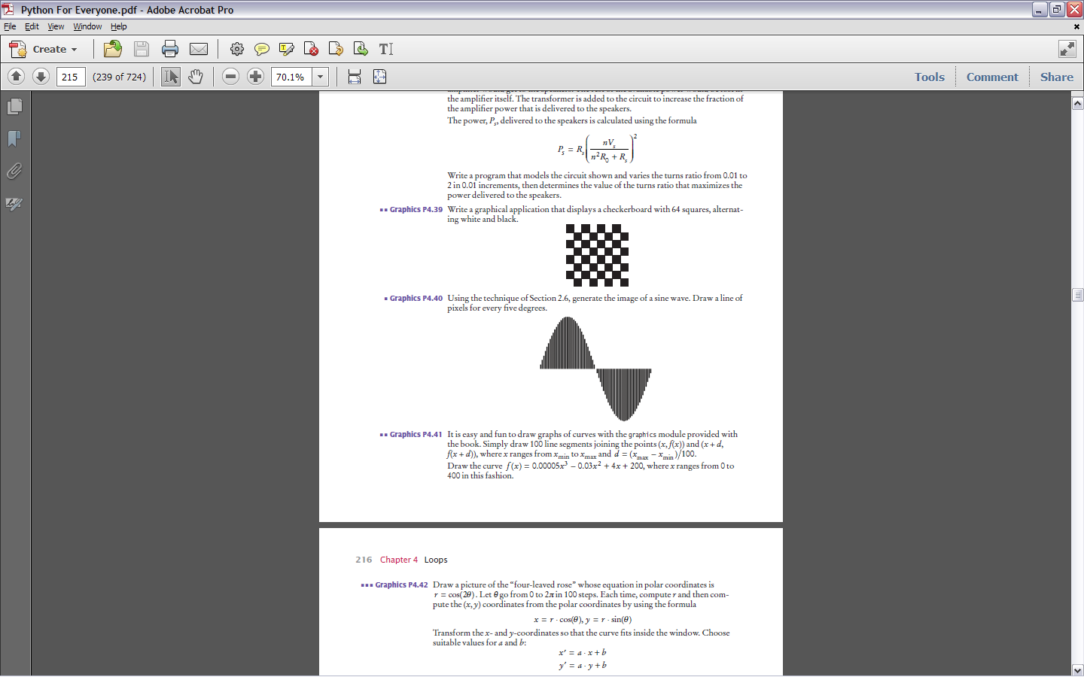

1. Write a function getTimeName(hours, minutes) that returns the English name for a point in time, such as "ten minutes past two", "half past three", "a quarter to four", or "five o'clock". Assume that hours is between 1 and 12.
2. Write a function that transforms numbers 1, 2, 3, …, 12 into the corresponding month names January, February, March, …, December. Also write some code to test your function.